**Spike:** Hunter Agent

**Title:** Hunter Agent

**Author:** Tran Duc Anh Dang | 103995439

**Goals / deliverables:**

Create a hunter-prey agent simulation for two or more agents, in which "prey" agents avoid "hunter" agents by concealing themselves **behind** objects in the environment. The simulation must:

* Include several "objects" that prey can hide behind (simple circles).
* Show a distinction between the "hunter" and "prey" agent appearance and abilities.
* Show an indicator ("x" or similar) to indicate suitable "hide" locations for prey to select from
* Prey agents must select a “good” location, and head to it, based on tactical evaluation.
* Do NOT hide “inside” objects – rather find a location outside (behind).

**Technologies, Tools, and Resources used:**

List of information needed by someone trying to reproduce this work

* Python 3+
* Built in Python libraries.
* IDE or Code Editor (Visual Studio Code)

**Tasks undertaken:**

* Install Python: Download and Install Python 3+ via https://www.python.org/downloads/
* Set up a code editor or IDE: Download and install a python compatible ide or code editor such as Visual Studio Code, PyCharm
* Open and familiarize with the code by reading through, paying attention to the comments that had been made.
* Run the code: Execute the code and observing the output.

**What we found out:**

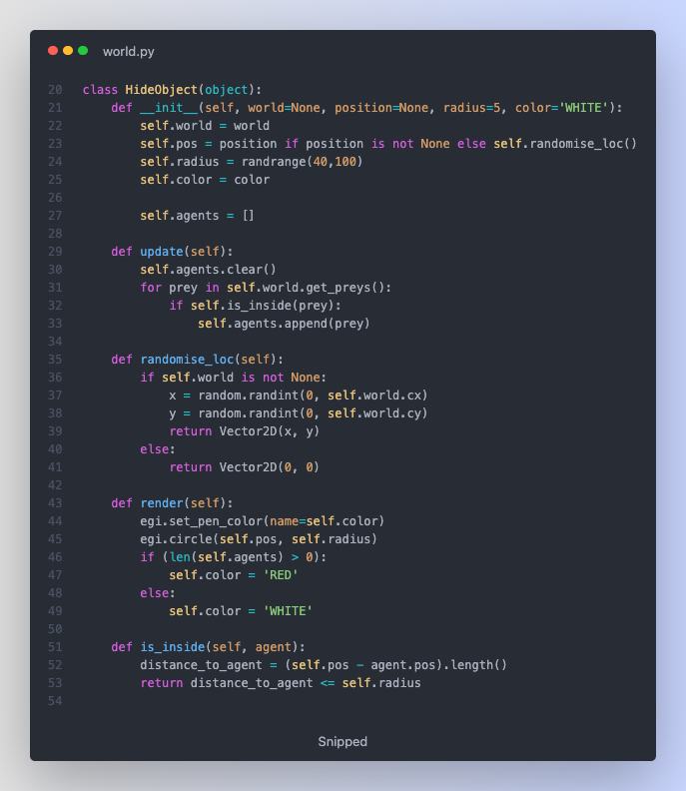

In this task, I have added HideObject as required, this object will be in circle that will change color once "prey" is trying to hide away from the "hunter". This has been demonstrating in the code above in update function as well as render. Once it is detecting if prey is inside the circle, it will add the list, and when the length of that list is > 0, the circle will change its color to red, otherwise it going back to its default color.

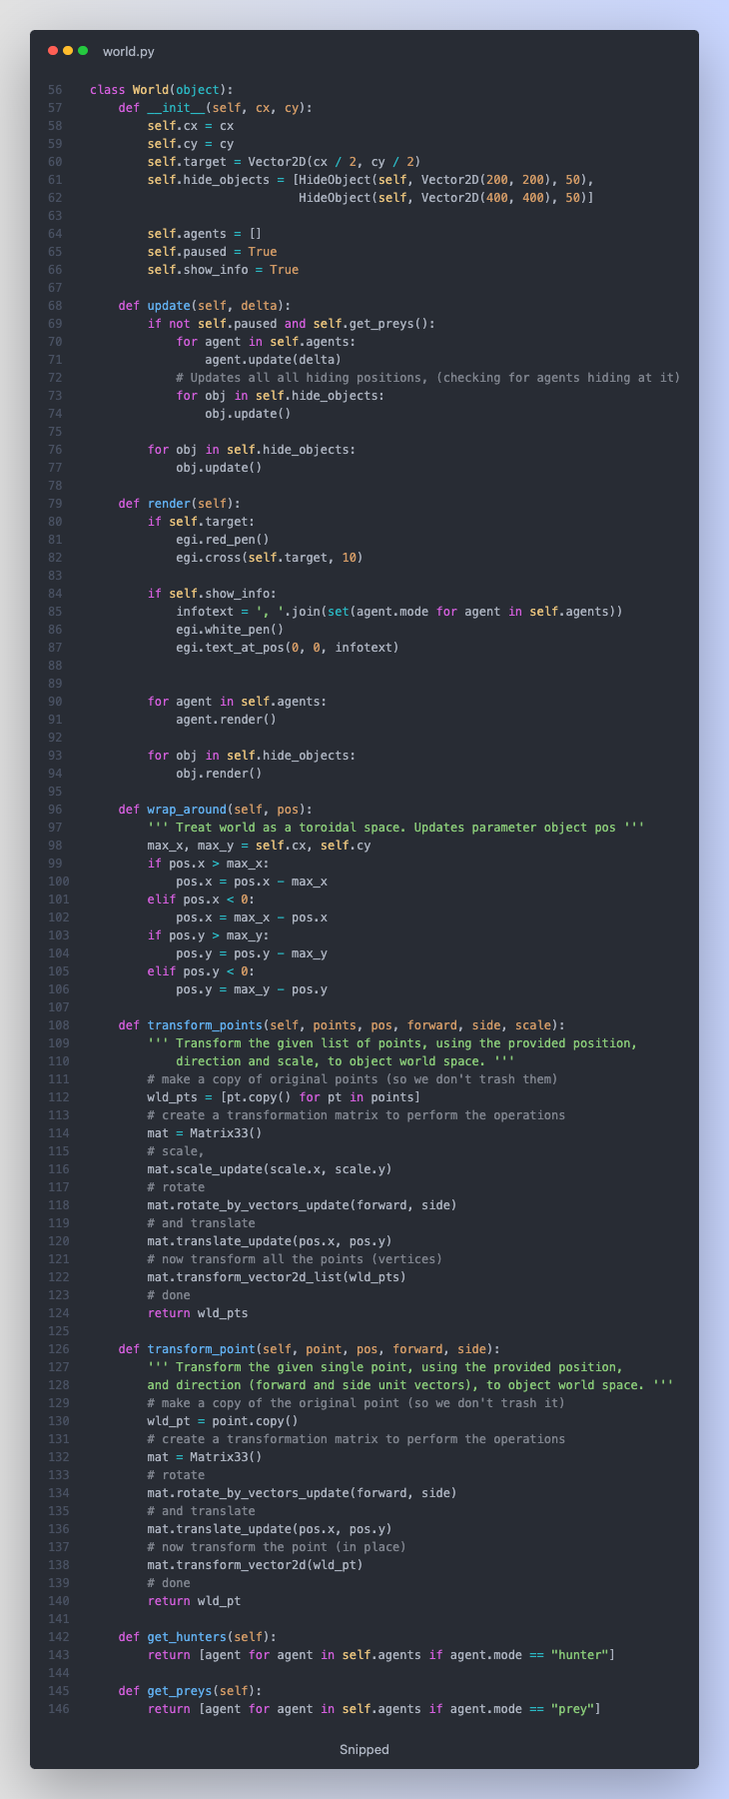

I have also updated the World class, I added functions get_hunters and get_preys to return a hunter or a prey defined word hunter/prey. And most likely the rest are the same.

In agent.py is where the most updated that I have. I have updated calculate function so I make hunter looking for prey to hunt and using wander as required. For the prey, it has 2 jobs, firstly, finding the hiding position, secondly detecting the closest hunter, if there is one it will increasing the hiding and fleeing force to seek for hiding object that furthest away from hunter that will be marked as identified hiding spot as required.

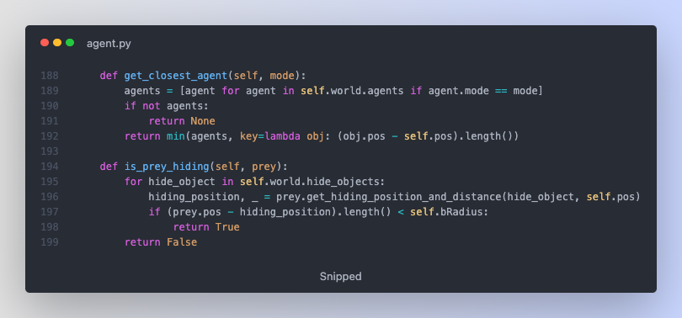

In this class, I also added 2 functions to find the closest agent (hunter or prey) and a function for hunter to check if the prey is hiding at that location.

Overall, I have completed what has been required to do in this task, there are a lot of things that needs to improve if I work on this task for the future.